Fareed Ahmed, Albert Chatfield, Marques Walker

Software Develope

**Shopping Cart User Manual**

1. Once in shopping cart start by viewing the items.

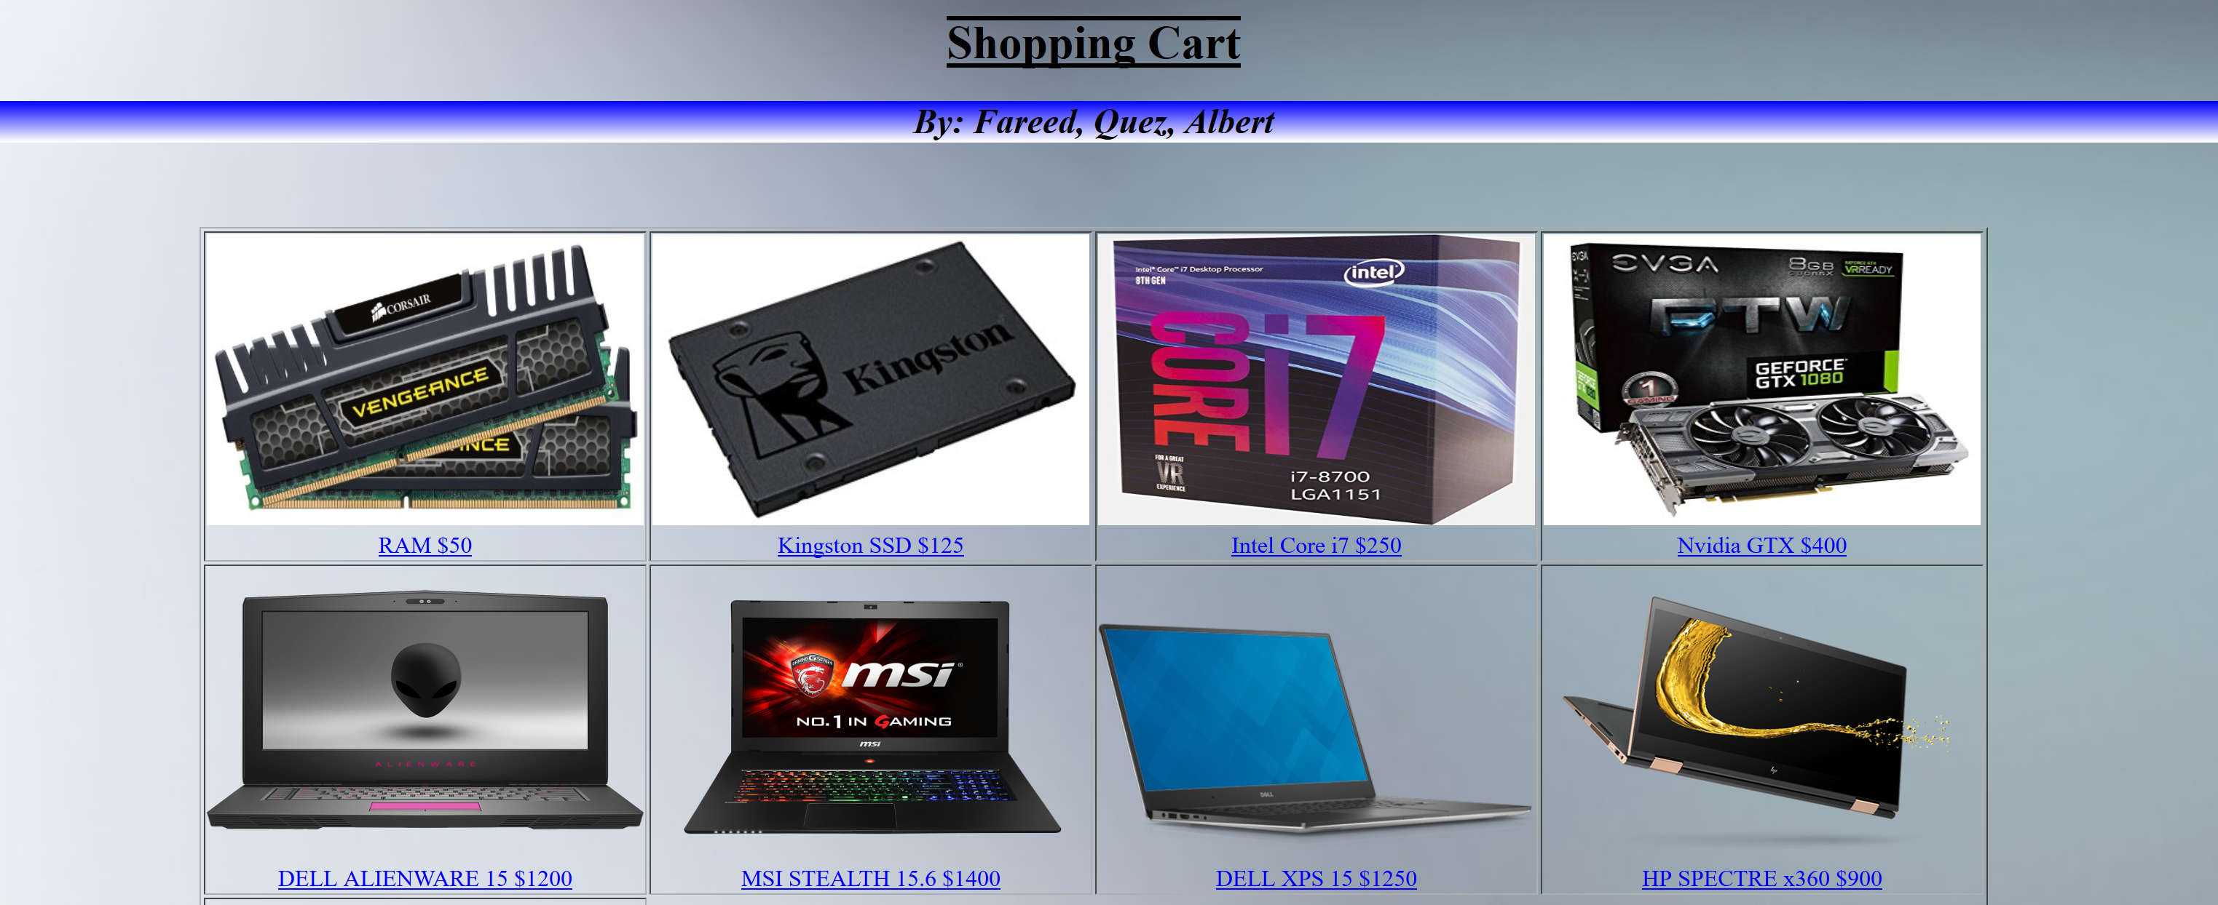

1. Click on desired item(s) that you want. The quantity of the idea(s) will be displayed in the Your Cart section, along with the total value without tax next to Total Cart.

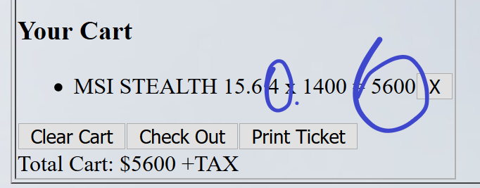

1. The title of the item will appear along with the price value of the combined quantity for each specific item also under Your Cart.

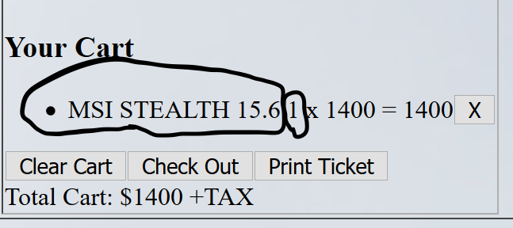

1. If you need to delete a selected item click the button with the X next to item and it will delete one of the selected item or click the Clear Cart button to clear everything in your cart.

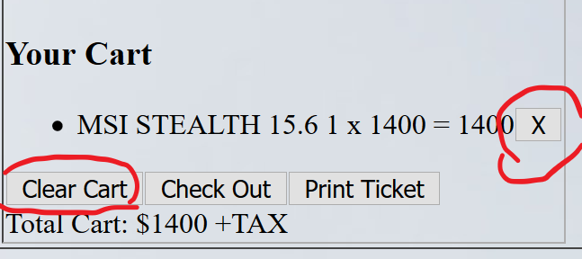

1. When you click the Check Out button an alarm will pop up and tell you whether you have to pay in cash or if you are able set up a credit line. (If you have a balance under $100.00 then you have to pay in cash, if you accumulate a balance over $100.00 then you can set up a credit line.)

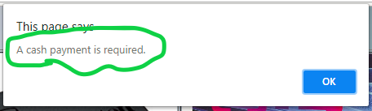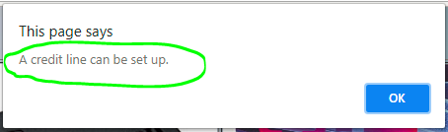

1. Click on the Print Ticket button and you will get the price of your Total Cart plus tax.

